# Software Engineering Project Report

**Report:**   
This report shall be submitted in three steps:  
      1.   Part 1 (Section 1 Customer Problem Statement  and   Section 2 System Requirements)  
      2.   Part 2 (Section 3 Functional Requirements Specification  and  Section 4 User Interface Specification )  
      3.   Entire Report

**Software Engineering Project Report**

Prepared by

GAJENDRA GOSWAMI

DIVYAM SINGH THAKUR

DEVASHISH BHAND

**CAR IN YOUR MIND**

**Problem domain**

SECTION 1

This is the developing world where everyone wishes to feel his life with comfort and luxuries.

Most of the people have confusions for the car.

Which car should they buy?

Which will be their pocket friendly?

Which car will provide more space?

Which car will be having greater mileage?

And all about their specifications and technologies…

# Solution domain

To solve this issue as an aspiring engineer on the field of computer science and engineering we are trying to make a software regarding car problems by which a customer can get full details by just entering their area of interests.

This will include all important features like car specifications, car design, car maintenance, car insurance, car allowability, car budget, car mileage, car backup, about the airbags, space, and all-important features which the customer is seeking for!

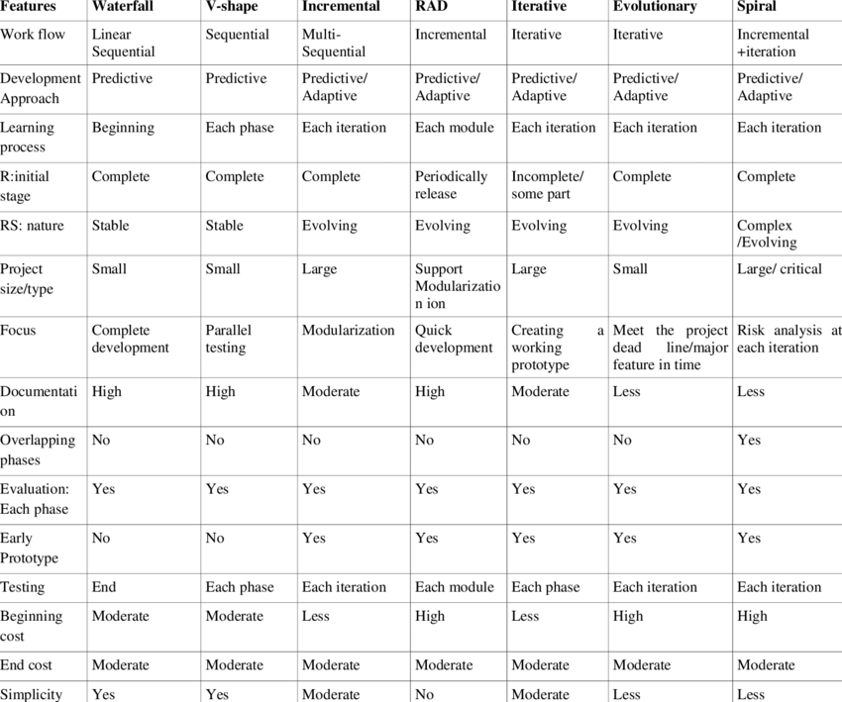

**The presentation layer:**It contains all categories related to the presentation layer.(car display…original documents)

**The business layer:** It contains business logic.(for profit motto)

**The persistence layer:**It’s used for handling functions like object-relational mapping(for user and dealer friendly relations)

**The database layer:**This is where all the data is stored.(data is being stored in whatever positions )

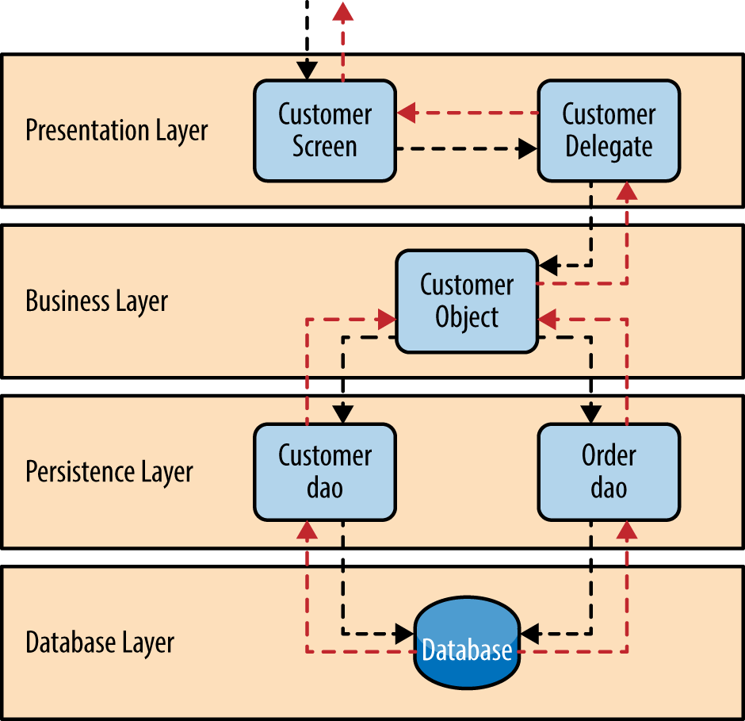

**SECTION 2**

**Agile model**

Agile SDLC model is a combination of iterative and incremental process models with focus on process adaptability and customer satisfaction by rapid delivery of working software product. Agile Methods break the product into small incremental builds. These builds are provided in iterations. Each iteration typically lasts from about one to three weeks. Every iteration involves cross functional teams working simultaneously on various areas like −

* Planning
* Requirements Analysis
* Design
* Coding
* Unit Testing and
* Acceptance Testing.

in our model we will be using agile software development model because this is a current and every time repeated topic because lots of cars get launched back to back so to adjust them in our software and according to user needs we have to use this model. since to add some of the car we cant use other models and write other engineering requirements again..this models helps in consuming time as well also previously stored data remains back to hold the data accurately.

**Agile manifesto and its 12 principles**

1. Our highest priority is to satisfy the customer through early and continuous delivery of valuable software.

2. Welcome changing requirements, even late in development. Agile processes harness change for the customer’s competitive advantage.

3. Deliver working software frequently, from a couple of weeks to a couple of months, with a preference to the shorter timescale.

4. Business people and developers must work together daily throughout the project.

5. Build projects around motivated individuals. Give them the environment and support they need, and trust them to get the job done.

6. The most efficient and effective method of conveying information to and within a development team is face-to-face conversation.

7. Working software is the primary measure of progress.

8.Agile processes promote sustainable development. The sponsors, developers, and users should be able to maintain a constant pace indefinitely.

9. Continuous attention to technical excellence and good design enhances agility.

10. Simplicity–the art of maximizing the amount of work not done–is essential

11. The best architectures, requirements, and designs emerge from self-organizing teams.

12. At regular intervals, the team reflects on how to become more effective, then tunes and adjusts its behavior accordingly.

**SECTION 3  
What is a Functional Requirement?**

In software engineering, a functional requirement defines a system or its component. It describes the functions a software must perform. A function is nothing but inputs, its behavior, and outputs. It can be a calculation, data manipulation, business process, user interaction, or any other specific functionality which defines what function a system is likely to perform.

Functional software requirements help you to capture the intended behaviour of the system. This behaviour may be expressed as functions, services or tasks or which system is required to perform.

Functional requirement in our project

basically, our project is to determine which car best fits into your budget so the requirements will be

example:

Input from user: best car under 5 lacs.

output: name of the cars

performance

maintenance

mileage

other specifications related to the car

## What is Non-Functional Requirement?

A non-functional requirement defines the quality attribute of a software system. They represent a set of standards used to judge the specific operation of a system. Example, how fast does the website load?

A non-functional requirement is essential to ensure the usability and effectiveness of the entire software system. Failing to meet non-functional requirements can result in systems that fail to satisfy user needs.

Non-functional Requirements allows you to impose constraints or restrictions on the design of the system across the various agile backlog

Non functional requirement in our project

as soon as the user inputs the data and budget according to his needs the list will be appear in ten or less than ten seconds and also it will display the car.

Class diagram:-

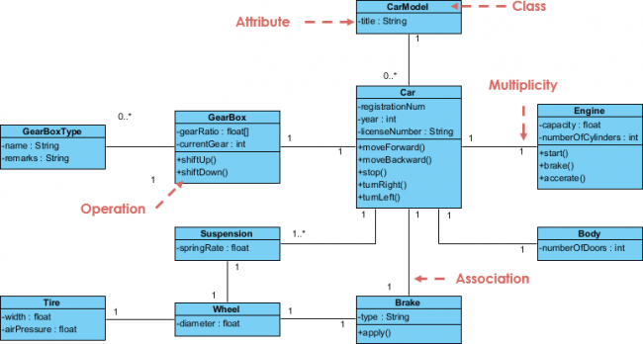

Use case diagram:-

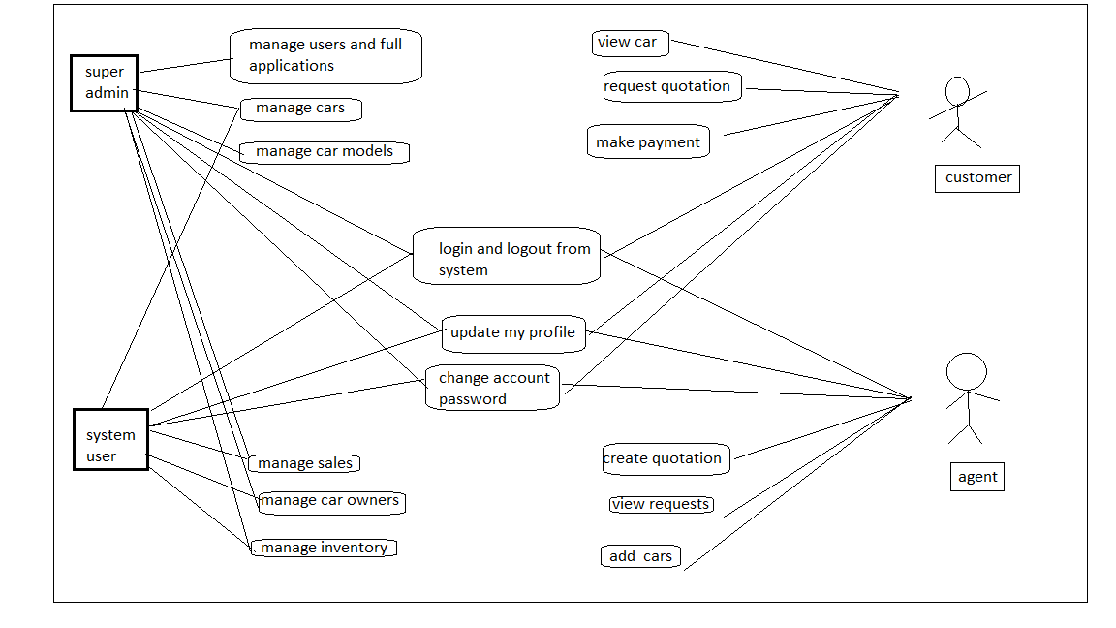

Activity diagram:-

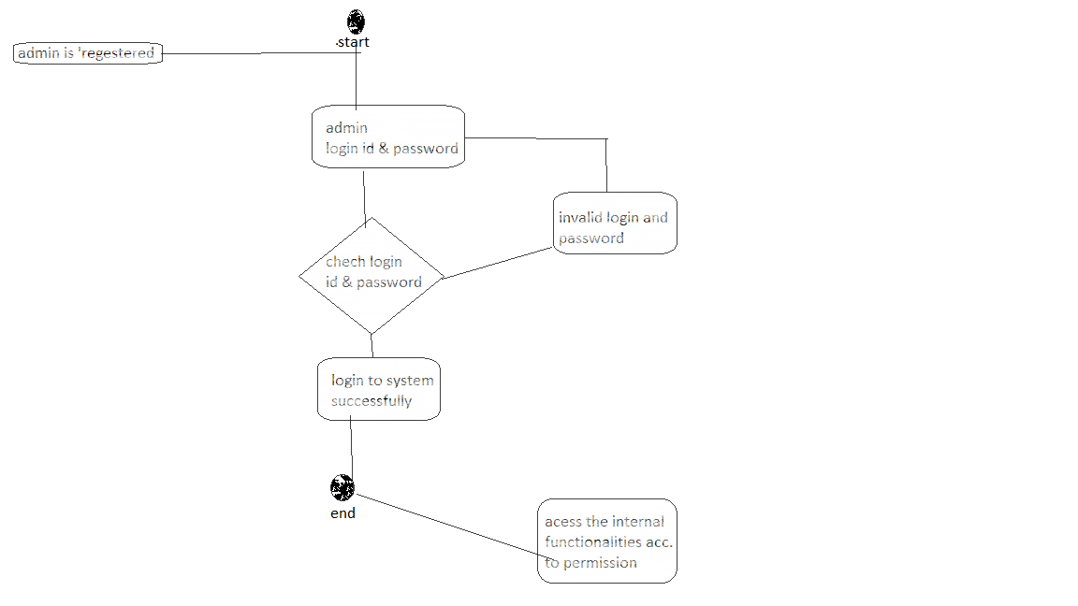

Sequence diagram:-

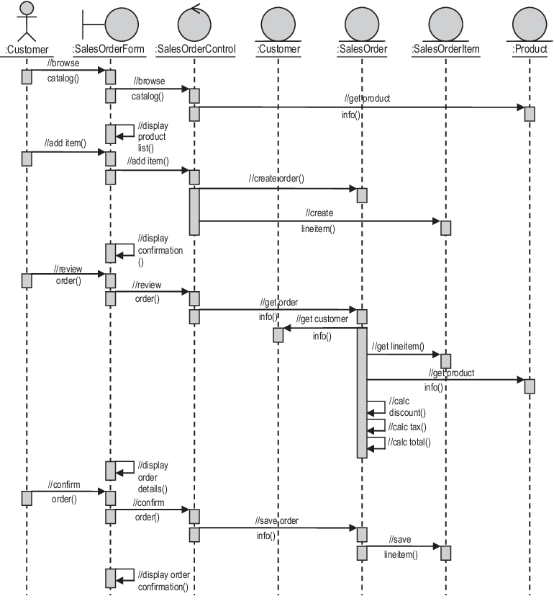

Data flow Diagram:-

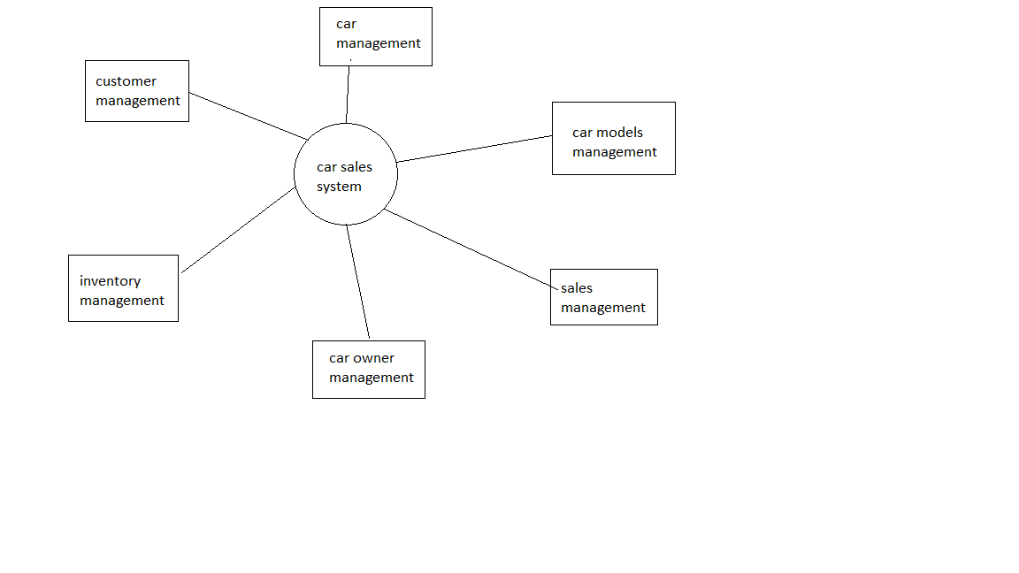

State machine diagram:-

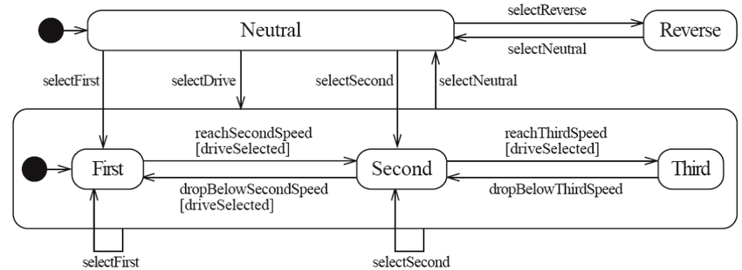

Communication diagram:-

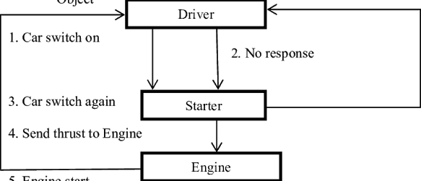

Package diagram:-

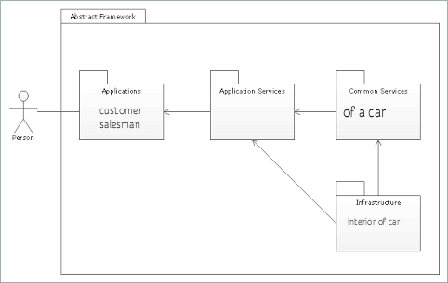

Composition diagram:-;

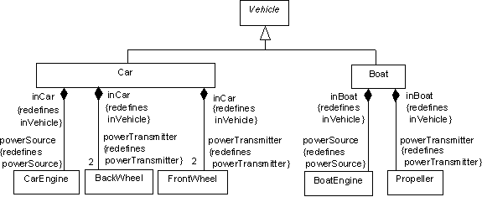

Various major testing strategies:

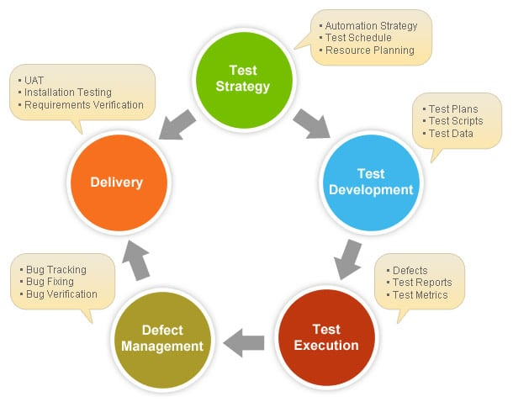

### **Types of Automotive Testing(cars)**

The tests you select for your components have their roots in the reasons you need testing. Tests encompass the durability of your parts and the environmental impact of operating them. Automotive testing procedures typically look at part durability or exterior resilience. These two broad categories have several tests within them, designed to verify your parts’ ability to measure up to the required standards.

### **1. Vibration Testing**

### **2. Climatic Testing**

### **3. Mechanical Testing**

### **4. Pressure Impulse Testing**

### **5. Emissions Control Systems Testing**

### **6. Emissions Bench Testing**

### **7. Cat Aging Testing**

### **8. SHED Testing**

### **9. Canister Loading Testing**

### **10. Coatings and Paint Testing**

### **11. Gravitometer Testing**

DETAILS:

### **1. Vibration Testing**

Driving creates constant vibrations on the vehicle’s frame and components. Our [**vibration testing**](https://www.nts.com/services/testing/dynamics/vibration/) puts the car through extremes to ensure durability. During vibration testing, ambient movements in the building itself can contaminate the results, but our facility accounts for environmental movement by using high-mass bases and air-bearing pads. These devices ensure our results are accurate.

### **2. Climatic Testing**

The environment plays a substantial role in the lifespan of automobiles and their components. Certain climates have conditions that foster premature wear. Hot and cold extremes can create stress on automotive parts. We put parts through[**environmental simulations**](https://www.nts.com/services/testing/environmental/) to see how long the components last. Climatic testing examines UV exposure, heat, cold, dry and wet conditions.

### **3. Mechanical Testing**

Mechanical operations can wear over time and become less efficient. With automobiles that rely on both electrical and mechanical systems running at their peak for the vehicle to continue working, physical operation testing is critical. [**Automotive mechanical tests**](https://www.nts.com/services/testing/mechanical/) include examining engine performance and efficiency from a variety of systems. We conduct leak detection, fluid dynamics analysis, stress testing and more. Our testing ensures your engines meet or exceed the regulatory requirements without sacrificing the performance consumers need from your brand

### **4. Pressure Impulse Testing**

Pressure impulse testing puts your system’s hydraulic components through their paces. Multiple systems use fluid movement to create mechanical motion. Regular tests ensure the system maintains pressure and operates as expected for the anticipated lifespan. New designs or models should undergo rigorous testing to prove their performance level matches or exceeds the previous iterations. Pressure impulse testing can help measure the effectiveness of the hydraulic system.

### **5. Emissions Control Systems Testing**

Reducing pollution is more important than ever. A single passenger car creates an [**average of 4.6 metric tons of carbon dioxide**](https://www.epa.gov/greenvehicles/greenhouse-gas-emissions-typical-passenger-vehicle) annually. In addition to carbon dioxide, internal combustion engines also release other harmful substances. To mitigate the effects of these pollutants on the environment, the federal government has set standards for emissions. Engine components and emissions systems must be tested to determine the amount of greenhouse gases they emit. Without appropriate testing, polluting engines could net their manufacturers hefty fines from both the federal and local government

### **6. Emissions Bench Testing**

The EPA has ever strengthening requirements for greenhouse gas emissions from on-road vehicles. A typical emissions bench can measure the amounts of [**carbon monoxide, methane, hydrocarbons, nitrogen oxides and carbon dioxide**](https://www.egr.msu.edu/ares/projects_small_engines_emissions.htm). Adhering to the EPA’s requirements is critical to avoid fines. Luckily, [**19 out of 21 vehicle manufacturers**](https://www.epa.gov/regulations-emissions-vehicles-and-engines/greenhouse-gas-ghg-emission-standards-light-duty-vehicles) did not carry an emissions deficit from 2016 to 2017. Companies that held debt had only three years to break even on greenhouse gas emissions by lowering the amounts from their vehicles to comply with federal standards. Between 2012 and 2025, the EPA will increase the standards, becoming stricter over time to reduce greenhouse emissions. Bench testing of gaseous outputs from an engine can verify compliance to guide the manufacturer to make changes to the engine’s design.

### **7. Cat Aging Testing**

As a catalytic converter ages, it becomes less efficient. The catalytic converter is an essential component of the emission control system. Some states have strict requirements for the catalytic converters that can be installed on cars sold in those places. Catalytic converter function is vital for the engine’s ability to adhere to emissions requirements, and premature failure of a catalytic converter could indicate a product that needs a redesign.

### **8. SHED Testing**

SHED stands for sealed housing evaporative determination. This testing method allows for the measurement of evaporative emissions from an engine. Due to stricter emissions laws, this type of automotive testing is likely to become even more popular in the coming years. The SHED is a measuring device that measures the emissions from a fuel system or a system component.

### **9. Canister Loading Testing**

Canister loading tests the filling and purging of evaporative emissions canisters. Testing the canister load and purge ensures the evaporative emissions system accurately cuts down on pollutants escaping from the fuel system. The ability of a canister to absorb and release fuel vapors is a crucial component of the evaporative emissions system. Without a canister that loads and purges appropriately, the vehicle will be more polluting and run much less efficiently.

### **11.Coatings and Paint Testing**

Testing paint and exterior coatings ensures those coverings prove as durable as expected. Our paint and coating tests include examining abrasion and weather resistance. Testers put the paint through the tests can they be used for vehicles.

### **12. Gravitometer Testing**

Gravitometer testing is another means of measuring a coating’s resistance to abrasions. In a gravelometer test, the samples have [**300 pieces of gravel**](https://www.nts.com/services/testing/materials/gravelometer/) heaved at them by the machine’s air pressure. How much of the coating gets chipped off determines the results of the test. We do our testing to ASTM and SAE standards, so the final scores from this test and all our automotive testing programs can be trusted to be accurate.

**Cost of maintenance:**

For these two models have been proposed

* *Belady & lehman model*
* *Boehm model*

*Basic equation is given by:*

M = P + ke^(c-d)

Where,

M= total effort expended

P= productive effort that involves analysis, design coding etc..

K= constant

C= complexity measure due to lack of good design and documentation

D= degree to which maintenance team is familiar with software

In our software (CAR IN YOUR MIND)

We are assuming it to be at professional level

Development efforts = 500 Persons/month

Empirically determined constant =0.3

Complexity of code(design, implementation, coding ) =8

Maintenance team has good understanding about software = 0.9

Then,

P=500

K=0.3

C=8

We know that

M=P+ke^(c-d)

= 500+0.3e^(8-0.9)

500 + 363.59 = 863.59PM

In case our team doesn’t get the actual meet and demand of software as per customer needs

Then,

M= 1309.18 PM